GeoGebra Instructions  - Website – www.geogebra.org  - Click on ‘Start GeoGebra’  - Click on ‘Geometry’  - Click on circle tab -  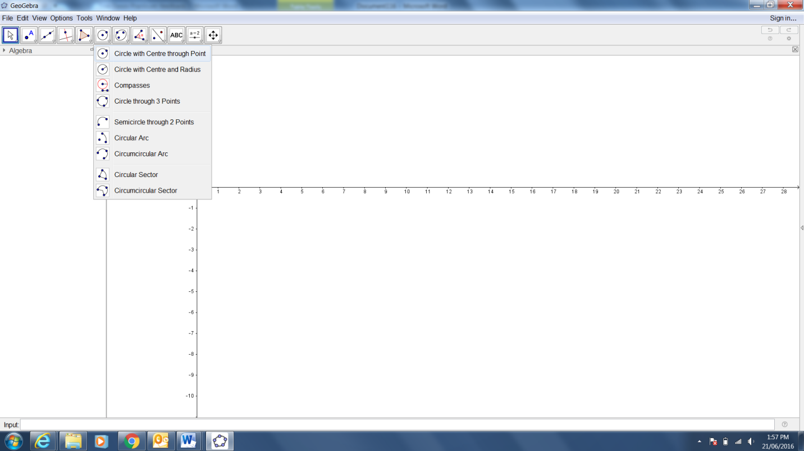  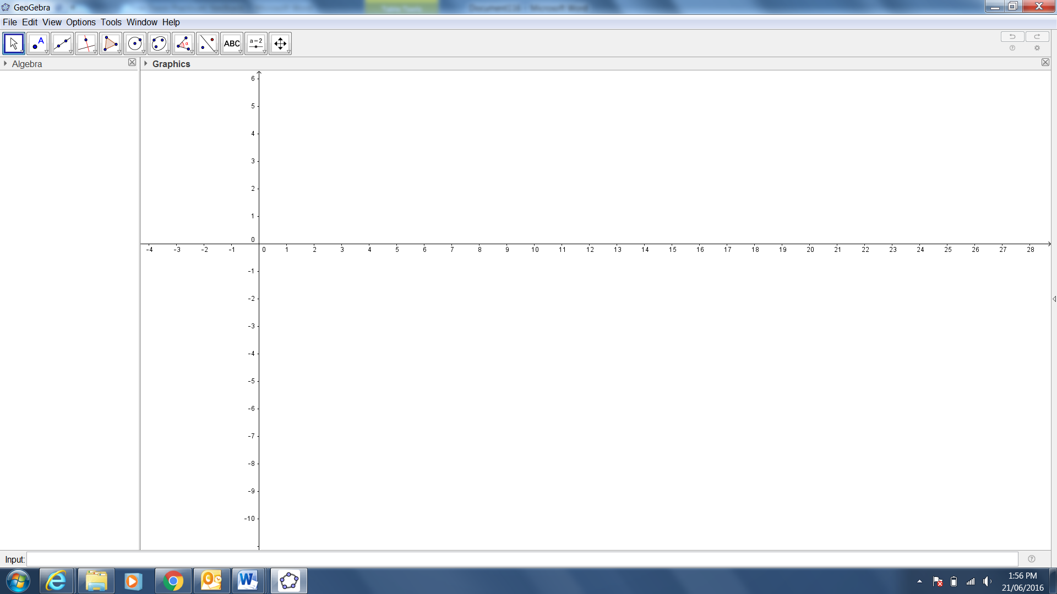  - Click on ‘Circle with Center through Point’    - Draw a circle.  - Click on  - Select ‘Segment’  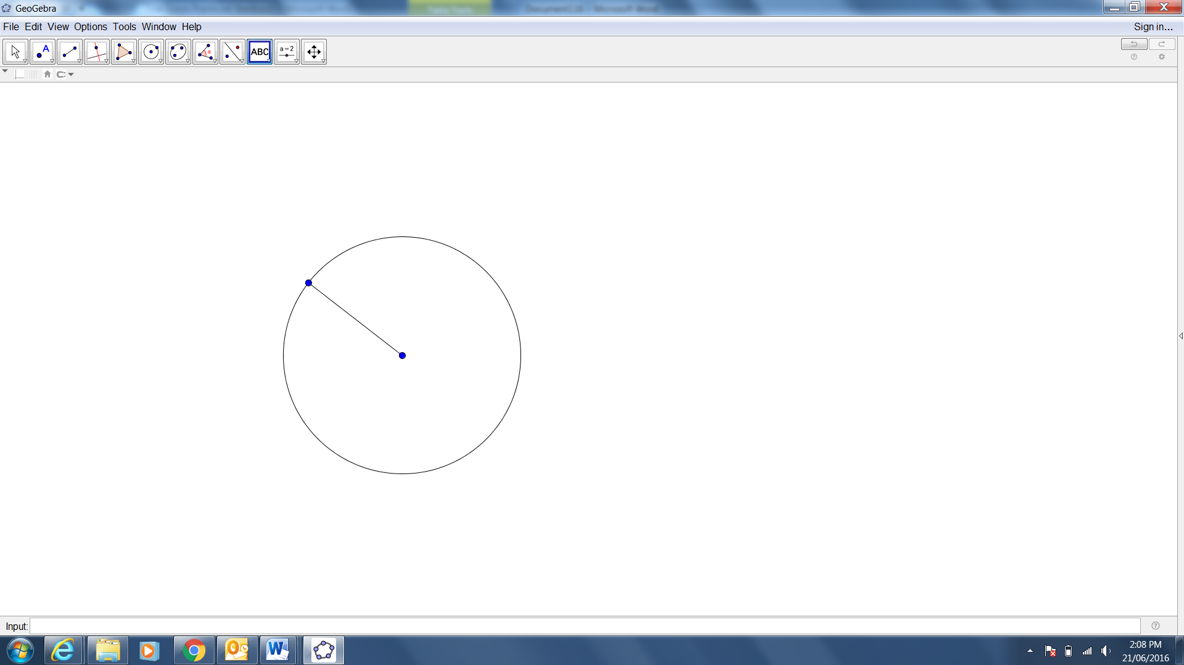  - Draw a line from the centre of the circle to the outside of the circle (join the dots with a line).  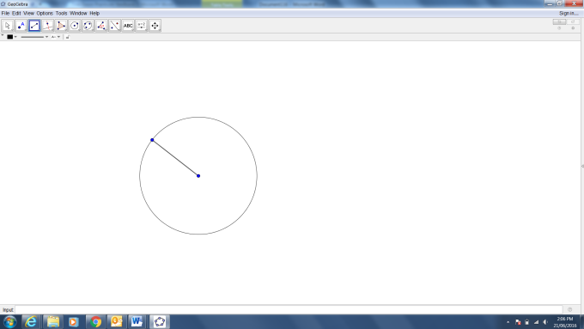  - Click on the ‘Angle’ tab.  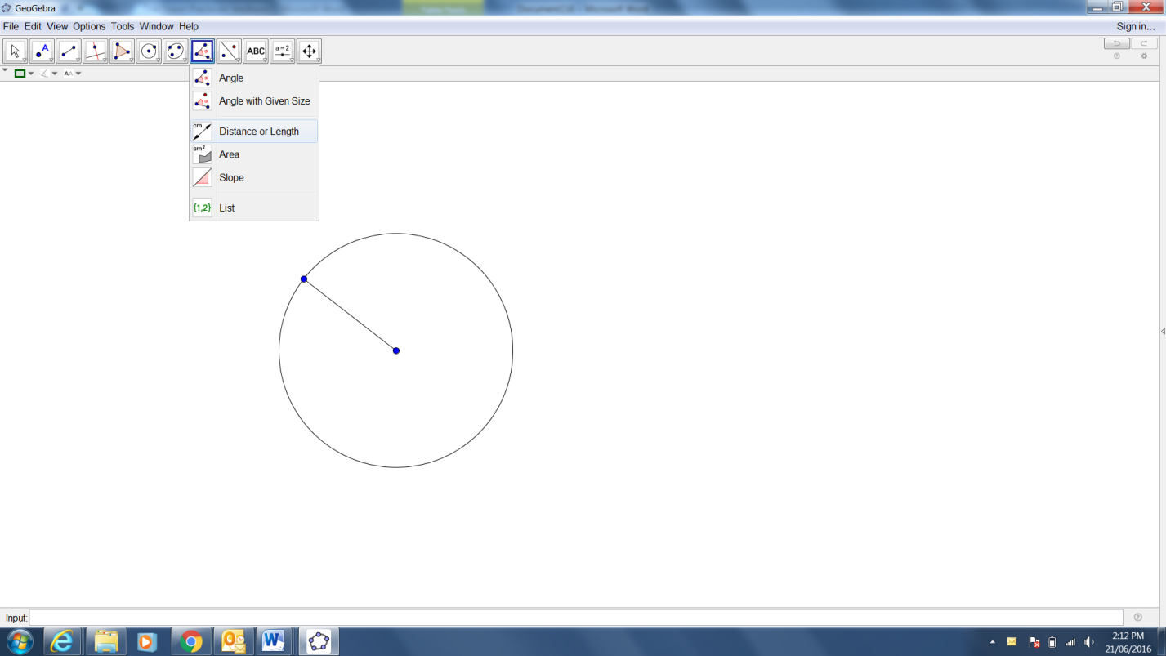  - Click on ‘Distance or Length’.  - Click on the radius to get the length and the circle to get the circumference.  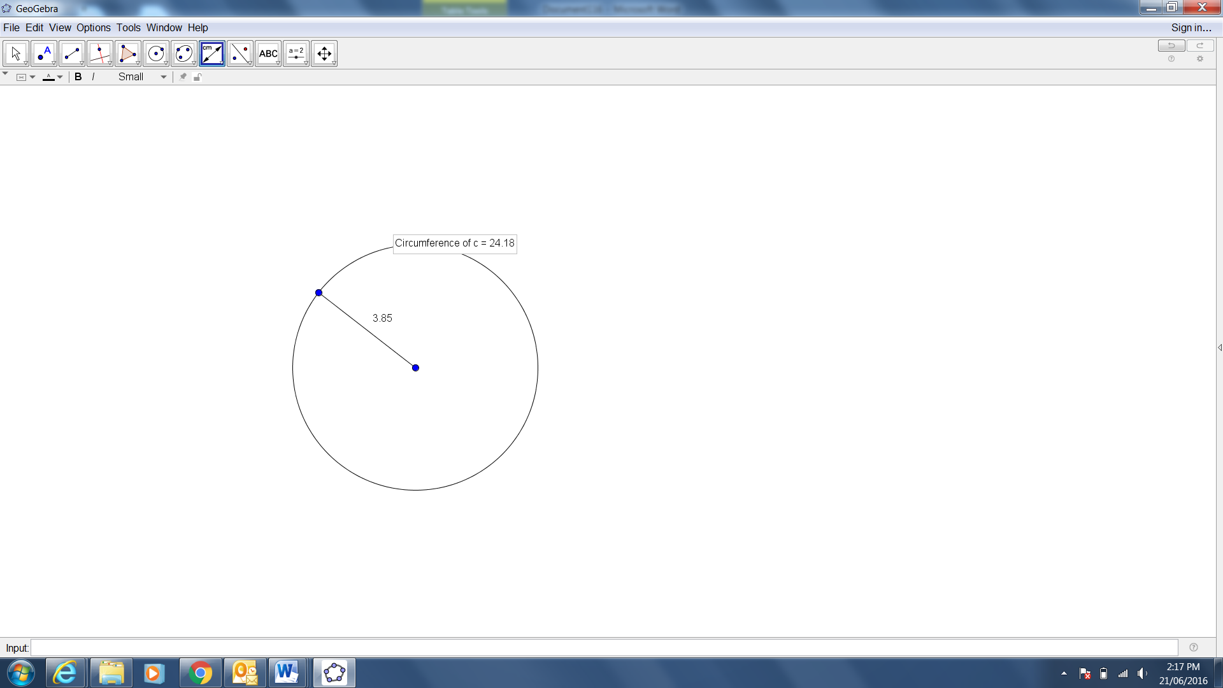 | GeoGebra Instructions  - Website – www.geogebra.org  - Click on ‘Start GeoGebra’  - Click on ‘Geometry’  - Click on circle tab -      - Click on ‘Circle with Center through Point’    - Draw a circle.  - Click on  - Select ‘Segment’    - Draw a line from the centre of the circle to the outside of the circle (join the dots with a line).    - Click on the ‘Angle’ tab.    - Click on ‘Distance or Length’.  - Click on the radius to get the length and the circle to get the circumference.  

GeoGebra Instructions
- Website – www.geogebra.org
- Click on ‘Start GeoGebra’
- Click on ‘Geometry’

- Click on ‘Circle’ tab


- Click on ‘Circle with Center through Point’


- Draw a circle.
- Click on
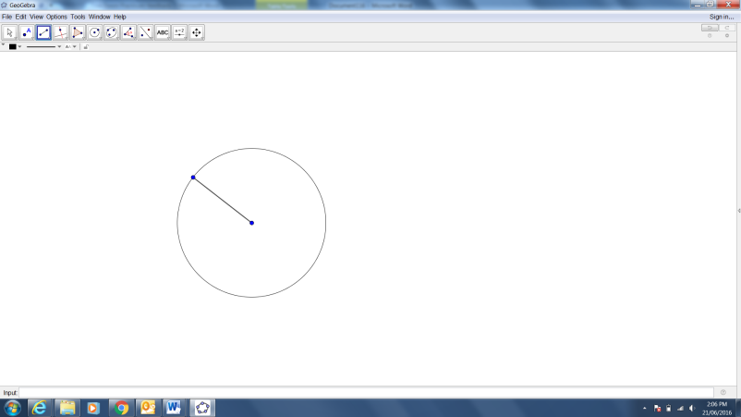
- Select ‘Segment’

- Draw a line from the centre of the circle to the outside of the circle (join the dots with a line).
- Click on the ‘Angle’ tab.

- Click on ‘Distance or Length’.

- Click on the radius to get the length and the circle to get the circumference.


